Question 1:

Design a flowchart, Pseudocode, Algorithm for processing a customer order at a restaurant,

including handling special requests (Like add on).

ALGORITHM:

Input customer order

Input order quantity

Check if it is available

Multiply the price with the amount of items he ordered respectively

Add up the individual costs to give a total sum

Print the receipt

Receive the money and give him the receipt

PSEUDOCODE:

Declare ItemName : STRING

Declare NumItems : INTEGER

Declare SinglePrice : INTEGER

Declare Sum : INTEGER

ItemName == “”

NumItems == 0

Sum == 0

PRINT (“How many items are you going to order?”)

INPUT (NumItems)

For x == 1 TO NumItems

PRINT (“Enter item number ” , x)

INPUT (ItemName)

IF TO_LOWER(ItemName) == “biryani”:

Sum = Sum + 200

ELSEIF TO_LOWER(ItemName) == “pulao”

Sum = Sum + 150

ENDFOR

Print(“The cost for your order is: ” , Sum)

FLOWCHART:

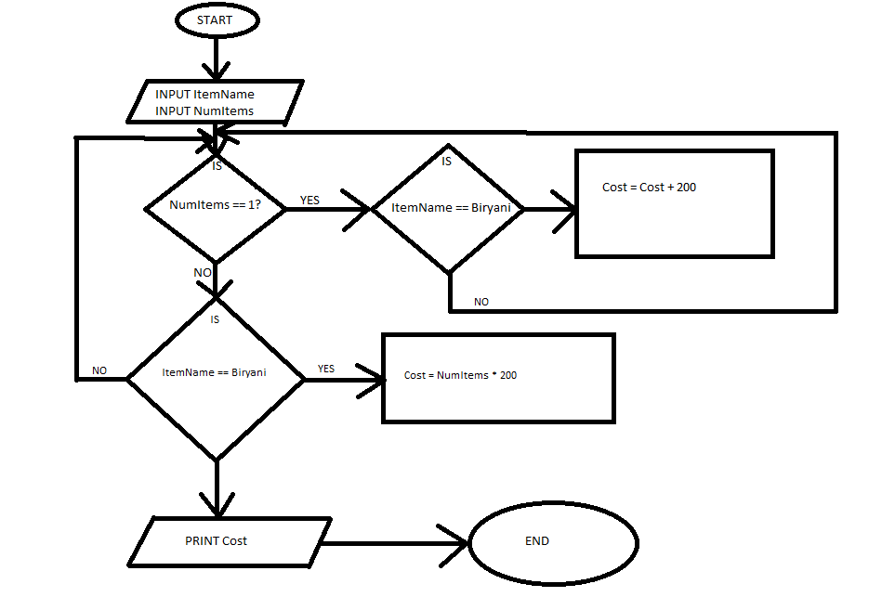

QUESTION 2:

Design a flowchart, Pseudocode, Algorithm for handling a customer's deposit transaction at a bank, including checks for account validity and deposit amount conditions.

PSEUDOCODE:

DECLARE AccountNum, DepositNum, TotalBalance : INTEGER

INPUT AccountNum, DepositNum

IF AccountNum <> 0 THEN

IF DepositNum > 0 THEN

TotalBalance = TotalBalance + DepositNum

PRINT (“The new total balance is: ” , TotalBalance)

ELSE

PRINT ("Enter a number that is greater than 0”)

END IF

ELSE

PRINT ("Invalid account number.")

END IF

ALGORITHM:

1. Ask user to enter account number and the amount needed to deposit
2. Check if account number is not something out of range. If it is out of range then print invalid number
3. Check if the amount deposited is not 0. If it is zero then ask user to enter number that is greater than 0
4. Once everything has been validated then add the deposited amount into the total balance of the user
5. Print the new balance with a prompt

QUESTION 3:

Design a flowchart, Pseudocode, Algorithm to determine which of three provided numbers is the greatest.

ALGORITHM:

1. Ask user to enter 3 numbers
2. Compare each number to the other 2 numbers to see which one is the biggest
3. After comparison, print the largest number

PSEUDOCODE:

Declare Num1, Num2, Num3 : INTEGER

INPUT Num1  
INPUT Num2

INPUT Num3

If Num1 > Num2 AND Num1 > Num3 THEN  
PRINT (Num1, “is the greatest”)

Elseif Num2 > Num1 AND Num2 > Num3 THEN  
PRINT (Num2, “is the greatest”)

Else

PRINT (Num3, “is the greatest”)

QUESTION 4:

Implement an algorithm where the user enters a number, and an appropriate month is

displayed.

1. Ask user to input a number between 1-12

2. Check if the number is actually between 1-12

3. If the number is out of range then ask for re input

4. Compare the months with the entered number (For example an input of 8 will result in August as an output as August is the 8th month).

QUESTION 5:

Create pseudocode a small calculator which only does ‘+’ or ‘-‘Operations. (Hint: Take three

variable inputs with one being used for the operator)

Declare Num1, Num2, Result : INTEGER

Declare Operator : STRING

INPUT Num1

INPUT Num2

INPUT Operator

If Operator == “+” THEN

Result = Num1 + Num2

Elseif Operator == “-” THEN

Result == Num1 – Num2

PRINT Result

QUESTION 6:

You are working at Toyota Indus Motors and want to assemble a car. Design a flowchart with

proper process modules and decision structures to replicate a pipeline production.

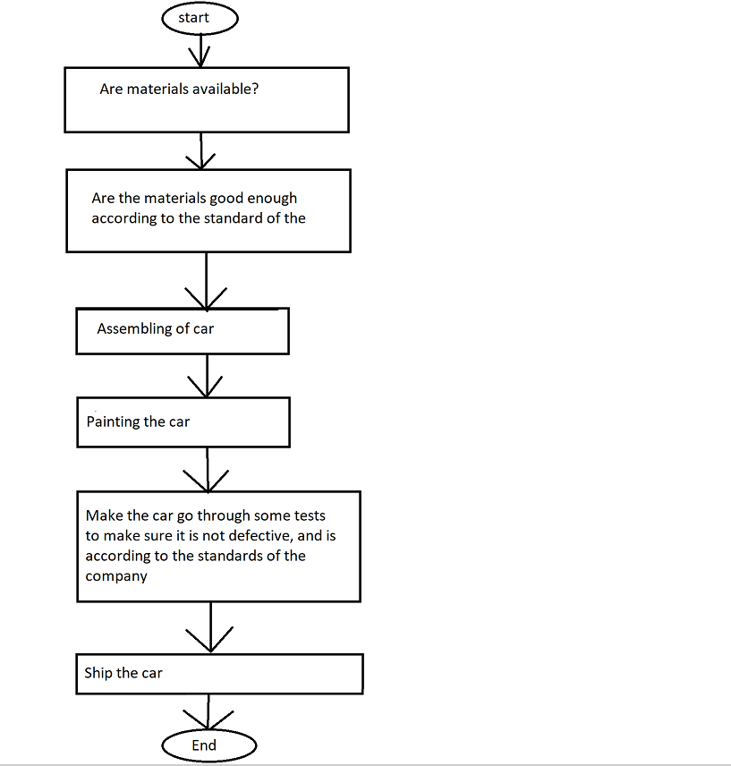

QUESTION 7:

Implement an algorithm for making a simple calculator with all the operators (+,-,*,/,%)

1. Input 2 numbers and an operator
2. If the operator is + then add the 2 numbers
3. If the operator is – then subtract the 2 numbers
4. If the operator is / then divide the 2 numbers
5. If the operator is * then multiply the 2 numbers
6. If the operator is % then it will give us the remainder on dividing the 2 numbers

QUESTION 9:

Why we use .gitignore?

A .gitignore file helps maintain a clean, efficient, and secure repository by ensuring only the necessary files are tracked by Git.

A .gitignore file is used in Git to specify which files and directories should be ignored by Git when you make changes to your repository.

__________________________________________________________________

QUESTION 10:

Difference between Algorithm and Pseudocode?

An algorithm is a step-by-step process to solve a specific problem. Pseudocode is a simplified version of programming codes and used to outline a program before its implementation.  
Algorithm is written in steps while pseudocodes are written in programming syntax